Your contact:

Oliver Kunzweiler
Director Central Marketing Weinig Group

Telefon +49 9341 86- 2169
Oliver.Kunzweiler@weinig.com

July 17th, 2023

Datum

PRESS RELEASE

WEINIG acquires shares in ESSETRE
Expansion of the Strategic Alliance to foster the
cooperation between the two companies

Essetre s.r.l. and Michael Weinig AG (Weinig) have formalized the
strategic alliance, already presented during Ligna Fair 2023.
With the acquisition of 50% of Essetre's shares by Weinig, the two companies will continue to develop strategically together as equal partners.

Together Essetre and Weinig are ready to face the challenges of the
international markets with an extraordinary prospect of development in terms of production and sales capacity.
Weinig and Essetre are very close in terms of innovation and technology. This collaboration will bring value for both brands:
Essetre will have access to Weinig sales and service network. Weinig will strengthen his market position.
"With this partnership and access to the product portfolio of Essetre, we are further strengthening our market position and can now offer our
customers the entire process chain, from the sawmill to timber construction, completely from a single source," says Gregor Baumbusch (CEO Weinig).

Essetre will continue to be managed by the Sella family.
GIOVANNI SELLA, founder of Essetre: “We would not have made such a collaboration with any other partner. Weinig and Essetre represent the top technologies in the market. We both have huge ambitions by combining our respective excellences. We trust it will be a strong and lasting growth.”

About the companies

WEINIG was founded in 1905 by Michael Weinig as a trading and
manufacturing company.
Since 1947, Weinig has specialized in the development and production of woodworking machinery and equipment for the solid wood processing industry and workshop businesses.
Weinig achieved sales of 586 million euros in 2022 and operates world-wide. The company employs a staff of 1,000 people at its headquarters in Tauberbischofsheim and around 2,500 in the Weinig Group
worldwide. Gregor Baumbusch has been CEO of the world market leader for solid wood processing since 2018.

ESSETRE
Essetre is specialized in the furniture and timber construction industry.
Founded in 1979 by Giovanni Sella, the family business is based in Thiene, province of Vicenza in Italy. Since then, Essetre has expanded its market to more than 30 countries and has been designing and manu-facturing 1200+ exclusive and branded CNC woodworking machines, i.e., 5-axis machining, wood construction, panels, and tops.
Essetre is a renowned specialist for wood machining centres, and above all for innovative solutions characterized by highest possible
efficiency and perfection.

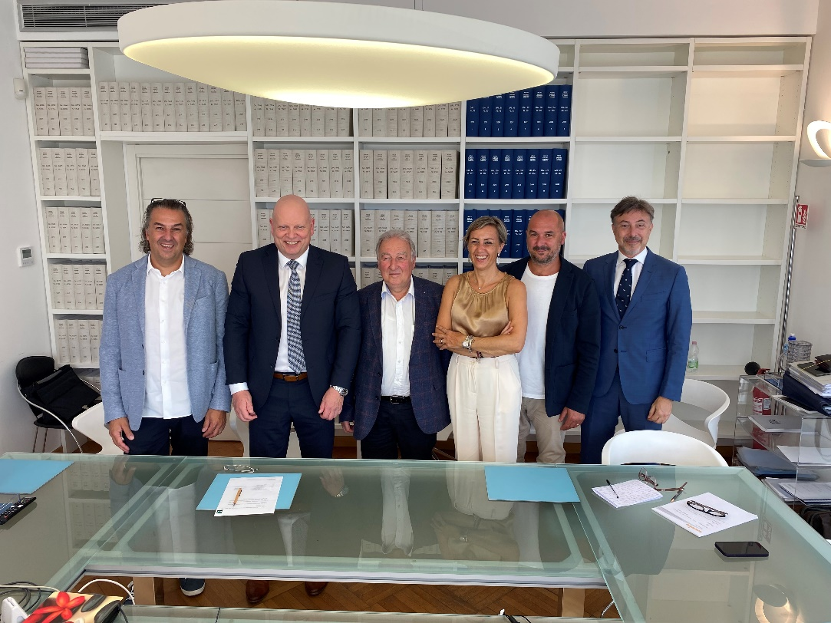
left to right: (Nicola Sella; Gregor Baumbusch; Giovanni Sella; Cristina Sella; Giuseppe Gherardi)

